### **Assumptions**

Each assumption is marked in the code with a comment indicating the assumption number. For example, “# ASSUMPTION 1” refers to the ingestion of the Transportation Tomorrow Survey data.

| **Driver Behaviour** | | | |
| --- | --- | --- | --- |
| **Assumption** | | **Realistic scenario** | **Reasoning for assumption** |
| 1 | Travel behaviour in electric vehicles will follow surveyed travel patterns from the 2016 Transportation Tomorrow Survey. | The population of Ontario has grown since 2016, and it is possible that EV drivers would plan their trips differently around charging sessions. | Travel behaviour data is only available from 2016. |
| 2 | Drivers will adopt electric vehicles at a uniform rate, in other words, a random percentage sample of historical travel profiles can be used to estimate the effects of that adoption level. | EV adoption rates will likely depend upon income level, number of public chargers available, access to at-home chargers, sociodemographic and other factors. | Counts of electric vehicles by forward sortation area are available on the Government of Ontario's Data Catalogue [1], but counts of total vehicles are not available, so geographically granular adoption rates are not possible to calculate. A random sample will not represent the true adoption rate, especially with early adopters, but at higher adoption rates, it could approximate the energy demand. |
| 3 | Trip distance can be approximated as the manhattan distance between start and end points. | Trip distance depends entirely on the road network and drivers' route choices. | The Transportation Tomorrow Survey does not collect trip end time or distance travelled along route. |
| 4 | Each person who drives on a survey day has their own vehicle. | Multiple people may share one vehicle, and some drivers could be using carshare services. | Vehicles are not tracked in the Transportation Tomorrow Survey. With linearization, the model electric vehicle uses the same energy whether two people take their sequential trips in two cars or one car. This may affect the time available to charge, as one driver may plug in for some time before the other driver unplugs and goes, plugging in later. In this scenario, our model would have a longer single charging period than the real two broken up charging sessions, but the same energy demand is captured. The model only considers trips taken as a driver, not as the passenger of a car . |
| 5 | Each person-vehicle pair can be expanded using their household’s expansion factor. |  | Person expansion factors are not provided in the TTS. |
| 6 | Travel times can be rounded to 5-minute periods of time. |  | Times are rounded to 5 minutes in the TTS. This is a convenient period length, as small time periods are computationally expensive, and larger time periods may lose the granularity of charging session length. |
| 7 | At each stop, a driver’s decision whether or not to charge follows the logic outlined in Figure 1. |  |  |
| **Chargers** | | | |
| **Assumption** | | **Realistic scenario** | **Reasoning for assumption** |
| 8 | Probability of a stop having a charger is uniformly distributed within categories of stop type and population density. | The distribution of public and private chargers has many factors as discussed in the literature review. | Probabilistic charger assignment based on stop type and population density is a starting point for analysing the impacts of charger access disparity. |
| 9 | Each charger has an identical power of 12 kW. |  |  |
| **Vehicle Mechanics** | | | |
| **Assumption** | | **Realistic scenario** | **Reasoning for assumption** |
| 10 | Vehicles travel can be approximated as a constant 50 km/hr. |  | The Transportation Tomorrow Survey does not collect trip end time or distance travelled along route, Manhattan distance and a constant speed is an approximation.. |
| 11 | If a vehicle is driving and reaches a 0% battery level, they continue driving and the battery level goes into the negatives. |  | The demand for energy is captured later when the vehicle charges. An alternative could be to add stops at public chargers to recharge or to determine a decision-making process for a driver to charge for longer earlier. |
| 12 | A vehicle’s initial battery level at time 0 can be simulated with the steady state battery level of the travel pattern’s repetition. | The vehicle would begin the new day at 12am with approximately the same state of charge as 11:59pm the day before. | Assuming the travel day represents an average travel day for that driver, initially randomizing the battery level then repeating the simulation for many days would replicate a vehicle beginning the day with its average 12am battery level. |
| 13 | Batteries charge and deplete linearly. | Lithium-ion batteries do not charge linearly, and have optimal state-of-charge ranges for battery health [2]. | Linear charging and depletion were assumed for simplicity. |
| 14 | Each person has an identical electric vehicle with the following parameters:   * Battery capacity: 100 kWh [3] * Energy per km: 0.195 kWh [3] | Battery and efficiency characteristics vary greatly depending on the type of car. | Single numbers were chosen for simplicity. Effects of varying the battery capacity can be seen in [report section]. |

Figure 1. Assumption 7, decision logic at a stop.

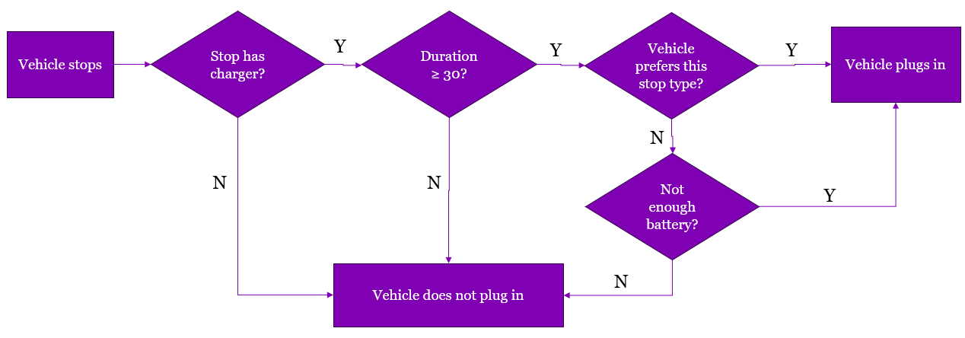

References

[1] “Electric Vehicles in Ontario – By Forward Sortation Area - Ontario Data Catalogue.” Accessed: Jan. 10, 2024. [Online]. Available: https://data.ontario.ca/dataset/electric-vehicles-in-ontario-by-forward-sortation-area

[2] E. D. Kostopoulos, G. C. Spyropoulos, and J. K. Kaldellis, “Real-world study for the optimal charging of electric vehicles,” *Energy Rep.*, vol. 6, pp. 418–426, Nov. 2020, doi: 10.1016/j.egyr.2019.12.008.

[3] “EV Database,” EV Database. Accessed: Dec. 18, 2023. [Online]. Available: https://ev-database.org/cheatsheet/energy-consumption-electric-car